GIAO DIỆN TỔNG QUÁT CÁC TRANG WEB

1. Admin:

Giao diện Dashboard:

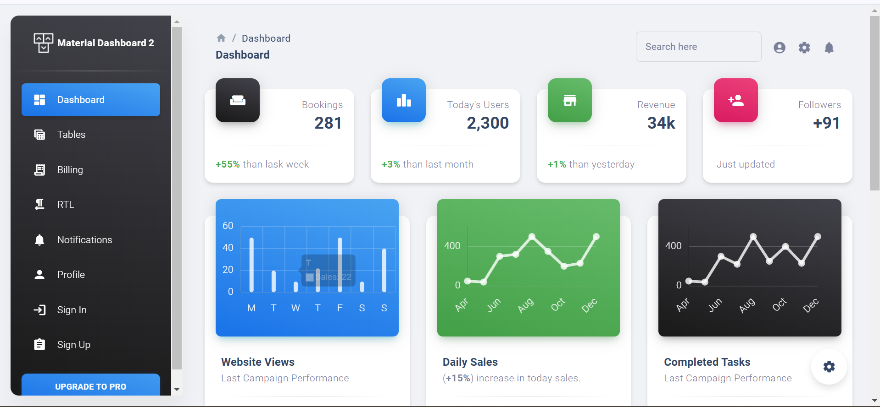

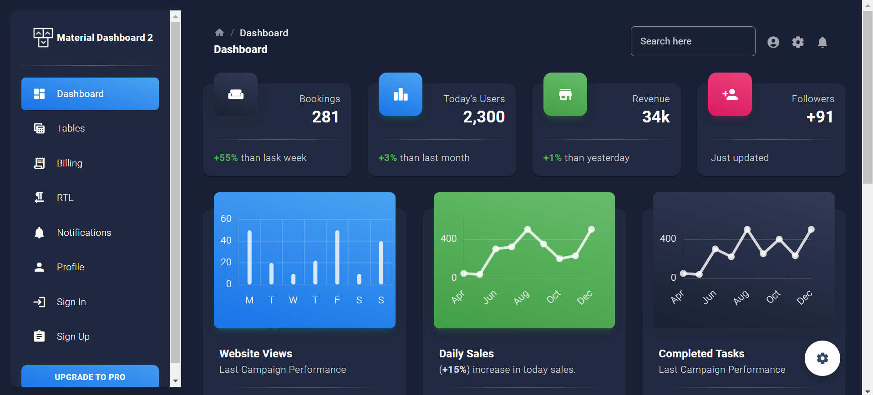

2. Giao diện tổng quát trang chủ:



